Group Business | CEIS Ayrshire
Job Title | Programme Manager, Family Forward Ayrshire
Department | Family Forward Ayrshire
Name of Post Holder
Reports to (Job Title) | CEIS Ayrshire Senior Leadership
Organisation Chart
(showing job in context of the organisation and programme)
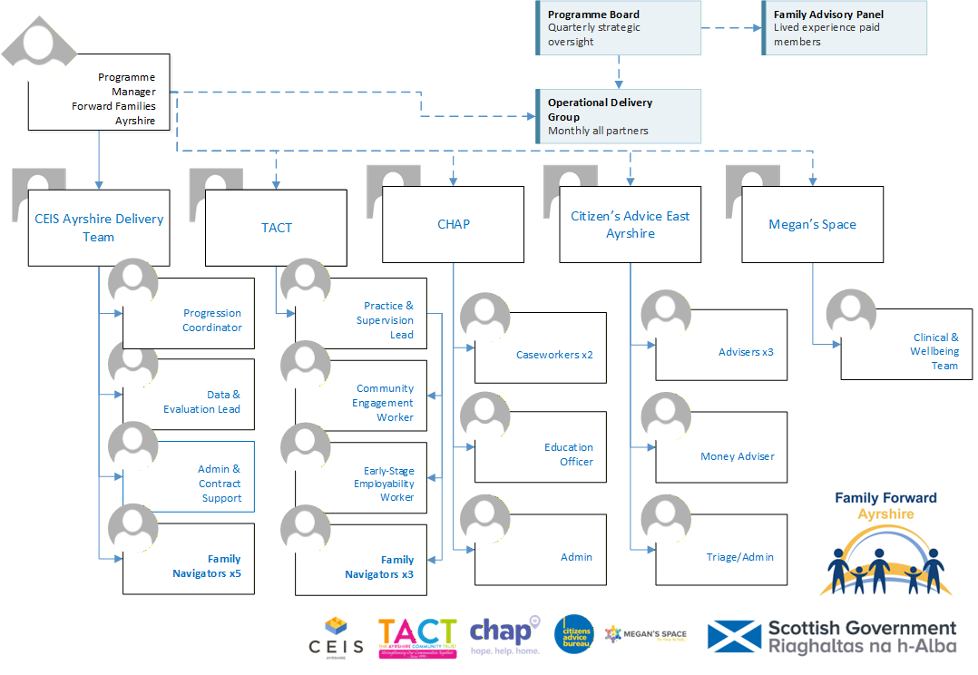

Location
Ayrshire (hybrid working with travel across North, East and South Ayrshire)
Contract
Fixed-term until March 2027 (renewal subject to future funding)
Hours
Full-time
Salary
£32,000 -£35,000 (dependent on experience)
Employer
CEIS Ayrshire

Job Context
(a description of the job in the context of where it fits in the overall structure of the Group Business and beyond if required).
CEIS Ayrshire operates within the social, economic and political environment concerned with the regeneration of disadvantaged communities. As lead organisation of the Family Forward Ayrshire partnership, CEIS Ayrshire is responsible for overall programme management, the funder relationship, and the delivery of CEIS-employed staff within the integrated operating model. Family Forward Ayrshire is a whole-family support programme across North, East and South Ayrshire, funded by the Scottish Government's Whole Family Support Third Sector Delivery Fund. The programme is delivered by a partnership of five organisations — CEIS Ayrshire (lead), TACT, CHAP, Citizens Advice East Ayrshire and Megan's Space — and will reach 431 families, securing £1.275m–£1.5m in direct financial gains and supporting 120–135 parents into work, better-paid work or accredited training. Every intensive family has one named Family Navigator and one co-produced plan; specialists work on shared caseloads inside that plan, not through referral chains.
Job Purpose
(a description of what the job entails and why it exists).
To lead the delivery of Family Forward Ayrshire: accountable for the programme achieving its contracted targets, for the health of the five-partner delivery model, for the funder relationship, and for building the evidence and relationships that carry the programme beyond its first funded period. This is a delivery leadership post — the Programme Manager sets the operational culture that determines whether shared-caseload working holds or regresses.
Assignment and Review of Work
(who the post holder reports to, and who will review their work, how and when this will happen).
The Programme Manager reports to CEIS Ayrshire senior leadership. Work is generated by programme delivery requirements and funder obligations. The post holder manages their own workload within programme priorities, with formal performance reviewed through the Programme Board (quarterly) and funder reporting cycles. The post holder is responsible for chairing the monthly Operational Delivery Group and for the day-to-day management of the CEIS programme team.
Key Deliverables
(a numbered list of the major KPIs and KDIs for the job).
- Own delivery of all contracted targets: 431 families reached, 225 intensive plans, £1.275m–£1.5m financial gains, 120–135 progression outcomes, 65% sustainment rate, 60%+ priority-group share.
- Chair the monthly Operational Delivery Group; resolve cross-partner casework, allocation and capacity issues at the lowest level and fastest speed possible.
- Manage the 7-month delivery shape: mobilisation completion by Month 2, intake engine through Months 3–6, outcome harvest in Months 7.
- Hold the programme risk register; escalate honestly and early to the Programme Board.
- Manage the four delivery sub-contracts (TACT, CHAP, CAB East Ayrshire, Megan's Space): performance, payment schedules, and working relationships.
- Defend the case-allocation protocol and correct regression to referral-chain working wherever it appears, in any organisation including CEIS Ayrshire.
- Line-manage the CEIS Ayrshire team with monthly supervision; maintain accurate caseload weighting; protect reflective practice time.
- Lead joint induction for all eight Navigators (CEIS Ayrshire and TACT) as one cohort with shared tools and standards.
- Service the quarterly Programme Board and bi-annual Thematic Sounding Board; ensure Family Advisory Panel members are paid, supported and heard.
- Own the funder relationship: quarterly reporting on schedule, proactive early notice of any material issue.
- Coordinate with Social Value Lab from Month 1; act on quarterly insight notes operationally.
- From Month 3, open and lead co-investment conversations with the three councils and HSCPs toward multi-year sustainability from 2027/28.
- Manage the CEIS Ayrshire programme budget against profile; oversee Family Support Fund governance; protect the contingency's restricted status.
Responsibility for Resources (direct or indirect)
(both human and other resources, description of other resources (if any).
Number of people: 8 direct/indirect (5 × Family Navigators CEIS, Progression Coordinator, Data & Evaluation Lead, Admin & Contract Support).
Their Job types: Family Navigators, Progression Coordinator, Data & Evaluation Lead, Admin & Contract Support.
Budgets: Over £1 million across CEIS Ayrshire programme budget; including TACT , CHAP, CAB East Ayrshire and Megan's Space allocations.
Communications and Working Relationships
Internal
- CEIS Ayrshire programme team (direct line management)
- CEIS Ayrshire senior leadership (reports to)
- CEIS Ayrshire finance (budget management and sub-contract payments)
External
- Partner operational leads: TACT, CHAP, CAB East Ayrshire, Megan's Space
- Three local authorities (North, East and South Ayrshire councils)
- NHS Ayrshire & Arran / Health and Social Care Partnerships
- DWP (maintaining voluntary-engagement boundary)
- Scottish Government — funder relationship and quarterly reporting
- Social Value Lab — independent evaluation interface
- Family Advisory Panel — lived-experience governance
Job Requirements
(qualifications, skills and experience – for job not specific job holder.
E = Essential, D = Desirable
 | Essential | Desirable
1 EDUCATION / QUALIFICATIONS
Relevant professional qualification or degree, or equivalent demonstrable experience |  | ü
2 EXPERIENCES
Substantial experience of managing multi-agency or multi-partner service delivery in employability, family support, advice, health or a related field | ü
Track record of delivering funded programmes to contracted targets, including funder reporting and budget management at £500k+ scale | ü
Demonstrable people leadership: supervision, caseload management, supporting staff doing emotionally demanding work | ü
Ability to hold partner organisations to shared standards while preserving the working relationships — evidence of resolving cross-organisational delivery problems | ü
Experience of commissioning or working with independent evaluation |  | ü
Experience of sustainability/co-investment development with local authorities or NHS |  | ü
Existing relationships within the Ayrshire public and third sector landscape |  | ü
3 KNOWLEDGE
Understanding of the drivers of child poverty and the Scottish policy landscape (Bringing Hope Building Futures, Whole Family Support, NOLB) | ü
Financial literacy sufficient to manage budget-vs-profile, sub-contract payments and audit requirements | ü
4 SKILLS AND ABILITIES
Ability to communicate with clarity and honesty with funders, partners and staff — including delivering bad news proactively | ü
Commitment to lived-experience governance — comfort being accountable to a paid panel of programme participants | ü
Ability to manage multiple concurrent workstreams across a complex multi-partner programme | ü
5 PERSONAL
Commitment to the values and ethos of Family Forward Ayrshire including voluntary engagement, trauma-informed practice and honest evidence | ü
Able to travel across all three Ayrshire areas and attend evening meetings as required | ü

Signature of Postholder
Signature of Manager
Job Description Compiled by
BH
Date Completed/Revised
17/08/2026
Job description should be reviewed annually v2 17/08/2026

